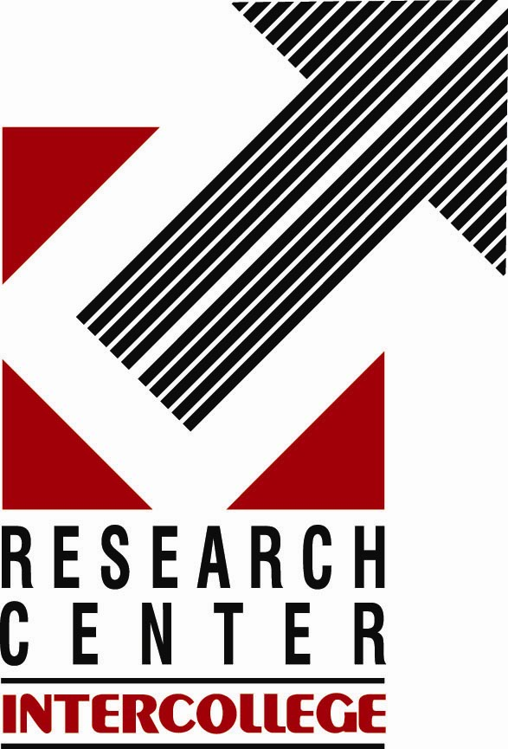
“SECURITY CHALLENGES IN THE 21ST CENTURY AND THE ROLE OF THE UN”

Conference organized by the

Research Center – Intercollege and

the United Nations Association of Cyprus

Monday, 11 December 2006

17:00

Unesco Amphitheatre, Europa Building
Intercollege, Nicosia

17:00 – 17:10 Registration

Chair: Michalis Attalides, Rector – Intercollege

17:10 – 17:15 Christos A. Theodoulou
President of the United Nations Association of Cyprus
Member of the Executive Committee of the World Federation of the United Nations Associations (WFUNA)

Welcoming Address

17:15 – 17:30 Michael Moller
Special Representative of the Secretary-General and Head of Mission, United Nations Peacekeeping Force in Cyprus

Opening Address

17:30 – 17:50 Jay Rothman
Fulbright Lecturer/Research Fellowship, President, The ARIA Group, USA
“The ‘New’ UN: Moving Towards Effective Conflict Prevention –
A Discussion of Challenges and Opportunities”

17:50 – 18:10 Alexander P. Shcherbakov
Minister – Counsellor, Embassy of the Russian Federation in Cyprus
“Security Challenges and the Role of the UN: A View from Moscow”

18:10 – 18:20 Andreas Theophanous
Professor of Political Economy, Department of European Studies and International Relations, Research Center – Intercollege
Comments and Reflections

18:20 – 18:50 Discussion

18:50 – 19:20 Reception

R.S.V.P. 22-841600, E-mail: rdc-i@intercollege.ac.cy

