
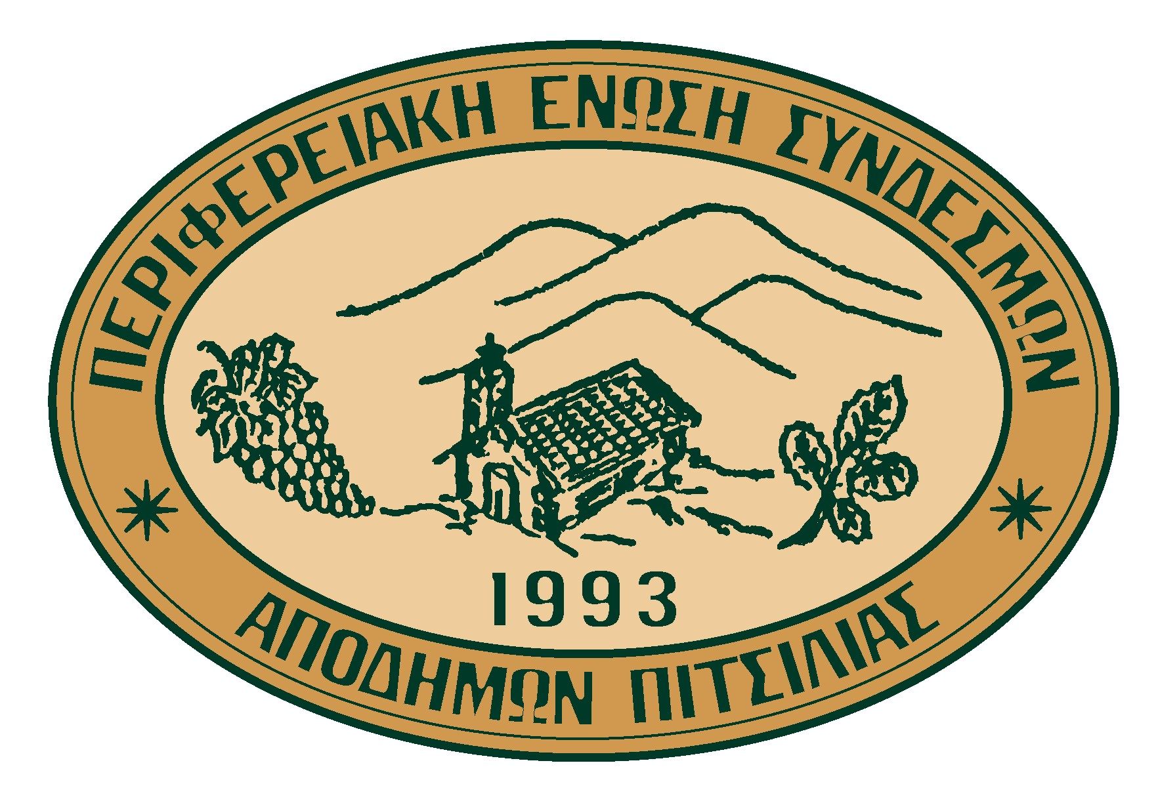

TOWARDS SUSTAINABLE DEVELOPMENT OF PITSILIA AREA

Organized under the “Sustainable Development of Mountainous Areas and Agenda 21” research project, by the Research and Development Center – Intercollege,
in collaboration with the Ministry of the Interior
and the Regional Union of Emigrant Associations of Pitsilia Area (PESAP)

Under the auspices of the Honorable Minister of the Interior Mr. Andreas Christou

AGROS VILLAGE, Saturday 25/06/2005
“Kelada” Cultural Center

AGENDA

09:00 – 09:30 | Registrations
 | Chair: Costas Papastavros
09:30 – 09:35 | Christophoros Papachristophorou  President of Agros Community Council  Welcoming
09:35 – 09:40  09:40 – 09:45 | Christodoulos Eliades,  President of PESAP  Welcoming  Panagiotis Damianou,  Secretary of the Union of Cyprus Communities  Welcoming
09:45 – 09:55 | Kyriakos Triantaphyllides  Member of the European Parliament  Opening Address
09:55 – 10:05 | Yiannakis Matsis  Member of the European Parliament  Opening Address
10:05 – 10:15 | Andreas Christou,  Minister of Interior  Opening Address
10:15 – 10:25 | Andreas Theophanous,  Director General of the Research and Development Center – Intercollege and Scientific Coordinator of the project  The importance of the salvation of the mountainous area of Pitsilia and the necessary requirements of its success
10:25 – 10:55 | Coffee Break
 | Chair: Andreas Theophanous
10:55 – 11:10 | Evi Eftychiou, Natassa Economou  Researchers, Research and Development Center - Intercollege  Presentation of the current situation of Pitsilia Area and the research that was contacted questionnaires
11:10 – 11:25 | Constantinos Constantinides, Giorgos Stavrou  Scientific partners for the project  Presentation of the Geographical System of Information
11:25 – 11:40 | Kyriakos E. Georgiou  Researcher, Research and Development Center - Intercollege  Action Plan – Economical and Social Dimensions of Sustainable Development – Administrative and Political Changes
11:40 – 12:10 | Discussion
12:10 – 12:25 | Coffee Break
12:25 – 12:40 | Costas Papastavros  Scientific Partner, Research and Development Center - Intercollege  Action Plan – Environmental Dimensions of Sustainable Development
12:40 – 12:55 | Anastasia Mavrelli  District Officer of Limassol  The role of the state in the policy making for sustainable development
12:55 – 13:10 | Marios Argyrou  Resident of Pitsilia  The resident’s role in the sustainable development of the area.
13:10 – 13:40 | Discussion
13:40 – 14:40 | Coffee Break

For more information please contact:
Evi Eftychiou – Tel. 22-841609, Fax: 22-355622 E-mail: ecognos@intercollege.ac.cy

